Project Planning Phase
Project Planning Template (Product Backlog, Sprint Planning, Stories, Story points)

Date | 26-06-2026
Team ID | Solo
Project Name | ShopEZ ecommerce application
Maximum Marks | 5 Marks

Product Backlog, Sprint Schedule, and Estimation (4 Marks)
Product Backlog & Sprint Schedule
Sprint | Functional Requirement (Epic) | User Story Number | User Story / Task | Story Points | Priority | Team Members
Sprint-1 | Registration | USN-1 | As a user, I can register for the application by entering my email, password, and confirming my password. | 3 | High | Solo
Sprint-1 |  | USN-2 | As a user, I will receive a confirmation email once I have registered for the application. | 2 | Medium | Solo
Sprint-1 | Login | USN-3 | As a user, I can log into the application by entering my email and password. | 3 | High | Solo
Sprint-1 |  | USN-4 | As a user, my session stays active via a JWT token so I don't have to log in repeatedly. | 3 | High | Solo
Sprint-1 | Dashboard | USN-5 | As a user, I can view a premium homepage with a responsive header and layout. | 3 | Medium | Solo
Sprint-1 |  | USN-6 | As a developer, I can connect the app to MongoDB Atlas and define Mongoose schemas. | 3 | High | Solo
Sprint-1 |  | USN-7 | As a developer, I can set up the Express server structure using ES Modules. | 3 | High | Solo
Sprint-2 | Catalog & Search | USN-8 | As a user, I can browse the full product catalog. | 3 | High | Solo
Sprint-2 |  | USN-9 | As a user, I can search for products by keyword with live results. | 3 | High | Solo
Sprint-2 |  | USN-10 | As a user, I can filter products by category, synced to the URL. | 3 | High | Solo
Sprint-2 | Product Details | USN-11 | As a user, I can view product specifications in a dedicated tab. | 3 | Medium | Solo
Sprint-2 |  | USN-12 | As a user, I can view product reviews in a dedicated tab. | 2 | Medium | Solo
Sprint-2 |  | USN-13 | As a developer, I can encode special characters in category URLs (e.g. Home & Kitchen). | 3 | Medium | Solo
Sprint-2 |  | USN-14 | As a user, I can browse the catalog comfortably on mobile devices. | 3 | Low | Solo
Sprint-3 | Cart | USN-15 | As a user, I can add or remove items from my shopping cart. | 3 | High | Solo
Sprint-3 |  | USN-16 | As a user, I can see a live price total in my cart, synced to the database. | 3 | High | Solo
Sprint-3 | Checkout | USN-17 | As a user, I can complete checkout in 3 steps: shipping, payment, confirmation. | 4 | High | Solo
Sprint-3 |  | USN-18 | As a user, I can pay using Card, UPI, or Cash on Delivery. | 3 | High | Solo
Sprint-3 | User Profile | USN-19 | As a user, I can edit my saved addresses in my profile. | 2 | Medium | Solo
Sprint-3 |  | USN-20 | As a user, I can view my order status history. | 3 | Medium | Solo
Sprint-3 |  | USN-21 | As a developer, I can sync cart state to MongoDB on every change. | 2 | Medium | Solo
Sprint-4 | Seller Analytics | USN-22 | As a seller, I can view KPI cards for Revenue, Orders, Pending, and Delivered. | 4 | High | Solo
Sprint-4 | Seller Inventory | USN-23 | As a seller, I can add, edit, and delete products via form modals. | 4 | High | Solo
Sprint-4 | Seller Orders | USN-24 | As a seller, I can search orders by ID. | 2 | Medium | Solo
Sprint-4 |  | USN-25 | As a seller, I can update order status from Pending to Delivered. | 3 | High | Solo
Sprint-4 | Deployment | USN-26 | As a developer, I can deploy the app on Render using a render.yaml blueprint. | 3 | High | Solo
Sprint-4 |  | USN-27 | As a developer, I can fix the seeder so bcrypt password hashing runs correctly. | 2 | Medium | Solo
Sprint-4 |  | USN-28 | As a developer, I can purge exposed .env secrets from the git history. | 2 | High | Solo

Project Tracker, Velocity & Burndown
Sprint | Total Story Points | Duration | Sprint Start Date | Sprint End Date (Planned) | Story Points Completed (as on Planned End Date) | Sprint Release Date (Actual)
Sprint-1 | 20 | 6 Days | 01 Jul 2026 | 06 Jul 2026 | 20 | 06 Jul 2026
Sprint-2 | 20 | 6 Days | 07 Jul 2026 | 12 Jul 2026
Sprint-3 | 20 | 6 Days | 13 Jul 2026 | 18 Jul 2026
Sprint-4 | 20 | 6 Days | 19 Jul 2026 | 24 Jul 2026

Project Tracker, Velocity & Burndown Chart: (4 Marks)
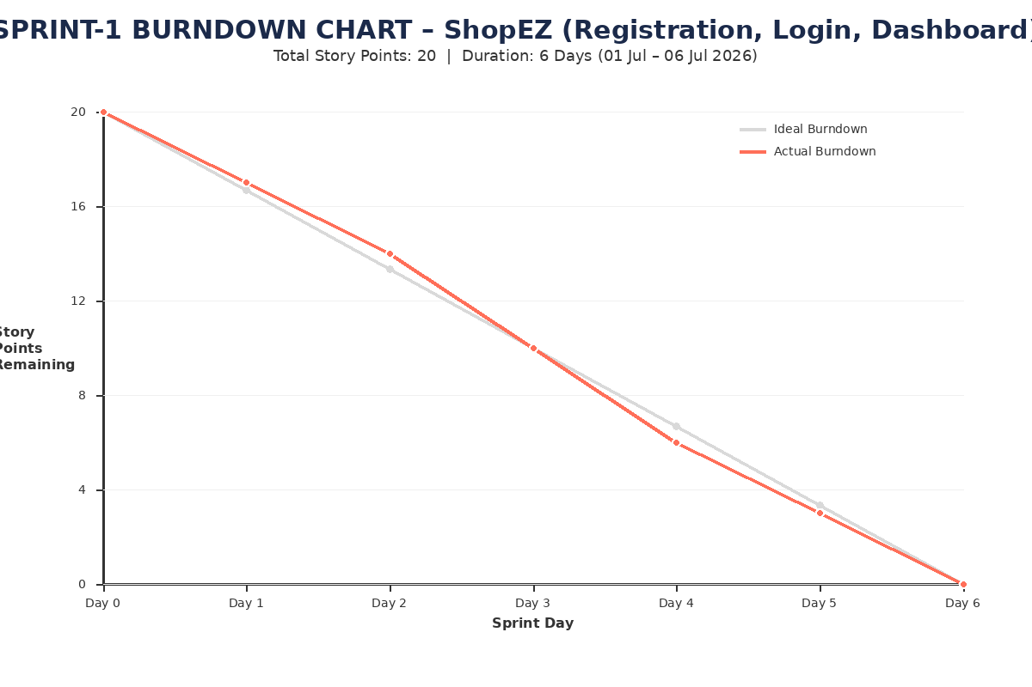

Sprint | Total Story Points | Duration | Sprint Start Date | Sprint End Date (Planned) | Story Points Completed (as on Planned End Date) | Sprint Release Date (Actual)
Sprint-1 | 20 | 6 Days | 20-06-2026 | 25-06-2026 | 20
Sprint-2 | 20 | 6 Days | 25-06-2026 | 30-06-2026 | 20
Sprint-3 | 20 | 6 Days | 30-06-2026 | 02-06-2026 | 20
Sprint-4 | 20 | 6 Days | 02-06-2026 | 06-06-2026 | 20

